GO AWAY RAA!
A Toolkit for Activists Fighting to Stop the Regulatory Accountability Act (S. 951)

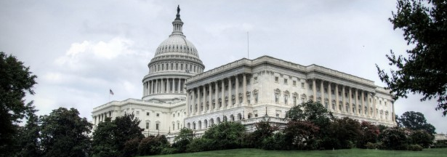
The RAA is a big business giveaway that would block lifesaving public protections and let corporations rig the rules.

Prepared by the Coalition for Sensible Safeguards
Contact: David Rosen, drosen@citizen.org, (202) 588-7742

Table of Contents

BACKGROUND
THE FIGHT AHEAD
TALKING POINTS
QUESTIONS FOR SENATORS
CALL SCRIPT
LETTERS TO LAWMAKERS
SAMPLE OP-ED
SAMPLE LETTERS TO THE EDITOR
SAMPLE TWEETS
SOCIAL MEDIA GRAPHICS
REBRANDING THE RAA
LINKS AND PETITIONS

Background

The Regulatory Accountability Act (RAA) (S. 951) is one of the greatest threats to our system of public protections in decades. The bill would rig the rulemaking process in favor of corporate deregulation, defeating continued enforcement of our public interest laws. The consequences of this legislation are incredibly broad – potentially impacting women’s health, consumer protection, food safety, financial reform, labor, the environment, disability rights, human rights, sustainable agriculture, rural development and more.

The RAA is designed to block or weaken regulations that protect American workers, consumers, families and our environment. It forces agencies across the board to adopt “the most cost-effective” regulations for corporations, instead of those that “maximize net benefits” to the public. This makes cost-benefit analysis, a flawed tool that undermines strong regulations, even worse by forcing regulators to put costs to industry before protecting our health and safety.

The RAA drowns agency regulators with 53 new requirements in the rulemaking process. These analytic and procedural hurdles have been shown to lead to significant additional delays, and the RAA provides no new funding for agencies to comply with these mandates. Given that agency budgets have stagnated or declined for decades, this will make it take longer for federal agencies to implement and enforce our laws.

The bill also revitalizes a long-discredited form of rulemaking for the most important regulations known as “adversarial hearings.” In the past, these chaotic, trial-like hearings led to enormous regulatory delay and dysfunction – which is why they were abandoned decades ago. Equally concerning, these hearings cut the public out of the rulemaking process and put corporate interests in the driver’s seat.

The RAA makes these adversarial hearings the exclusive record of decision-making for agencies when developing protections, rendering the public comment process largely irrelevant to rulemaking. It also vastly increases the influence of corporate lobbyists who have the resources to take advantage of these hearings to block or weaken regulations. If used for the most important regulations, Washington insiders and corporate lobbyists will have far greater influence over new regulations than the public.

Finally, the RAA offers opponents of regulatory safeguards dozens more opportunities to attack and kill regulations in court. All 53 of the RAA’s new procedural and analytical requirements will be subject to judicial review, creating a myriad of new ways for corporate interests to take agencies to court, stall new rules or block them entirely. The RAA also allows courts to overturn rules by second-guessing agency cost-benefit analysis, scientific justifications and agency expertise generally.

After the destruction wrought by the Congressional Review Act and President Donald Trump’s extreme “one-in, two-out” executive order on regulations, we cannot let the RAA permanently cripple federal agencies’ ability to enforce bedrock laws through strong and sensible regulations that protect the public.

The Fight Ahead in the U.S. Senate and at Home

An even more extreme version of the RAA than the one described here passed in the U.S. House of Representatives in January. No one expects that version of the bill to become law. However, the Senate version of the RAA (described above) stands a better chance, because it has token bipartisan support. It already has passed out of committee.

At some point in the next few months, possibly in the next few weeks, Senate Republicans may try to bring the RAA to the floor for a vote. The bill will need 60 votes to overcome a filibuster and then 50 for final passage. If the RAA passes in the Senate, it will be rammed through the House and signed by President Donald Trump within a matter of weeks. Blocking the RAA in the Senate is our ONLY CHANCE to stop the bill from becoming law and save our system of public protections.

In the fight against the RAA, every senator matters – Democrats, Republicans and Independents in all 50 states. The nearly 160 member groups in the Coalition for Sensible Safeguards and our allies are taking the fight to each and every one of these senators in their Washington, D.C., offices. But we need your help! To stop this terrible bill, both of your two U.S. Senators need to hear from you. Here are some things you can do:

- Ask a senator about the RAA at a town hall meeting.
- Call, email or write a senator about your opposition to the RAA.
- Write an opinion piece or letter to the editor about the RAA in your local paper.
- Post about the RAA on Twitter, Facebook and other social media platforms.
- Talk about the RAA at a local organization or community meeting.
- Sign a petition opposing the RAA and other anti-regulatory legislation.
- Share this toolkit with your friends, family, neighbors and allies.

This toolkit will help you take these actions. Please don’t wait to act or leave it to somebody else. The next few weeks are critical!

Talking Points

CORE MESSAGE: The RAA is a big business giveaway that would block lifesaving public protections and let corporations rig the rules.

Shutting Down Protections. Regulatory protections ensure that we have clean air and water, healthy food, safe products, fair workplaces, honest wages and other basic standards of living. The RAA would let big corporations shut down these protections and their enforcement.

Rigging the Rules. The RAA would rig the rules so that corporate profits always would come before protecting the public. It also would invite more interference from lobbyists, politicians and judges, while forcing regulators to go through a never-ending gauntlet of hurdles to hold Wall Street and big polluters accountable.

Excluding the Public. The RAA’s vague language – and in particular its revival of the outdated and chaotic adversarial hearing process for important public protections – would fulfill Steve Bannon’s vision of “deconstructing the administrative state.” It transforms the process into a high-cost “pay-to-play” game that cuts the public out of the loop and puts corporate lobbyists and lawyers permanently in charge.

Big Business Payback. President Donald Trump and Republicans in Congress are pushing the RAA as payback for funding their campaigns. It’s no accident that this bill will be a huge windfall for big business; that’s exactly what the U.S. Chamber of Commerce designed it to do.

Threatening Our Communities. The costs of deregulation are enormous. The Wall Street economic collapse, the Flint water crisis, food and product safety recalls and the BP oil spill all demonstrate the need for a regulatory system that protects the public. The RAA would leave millions of Americans vulnerable to job losses, wage cuts, public health crises and environmental disasters – letting giant corporations threaten entire communities and get away with it.

Tougher Enforcement Needed. Between Wells Fargo, Volkswagen, United Airlines, BP and Takata, we’re facing an epidemic of corporate crime and wrongdoing. Instead of taking the cop off the beat, we need tougher enforcement of our laws to ensure that CEOs are held accountable and that everyone plays by the same set of rules.

Questions for Senators

The questions below can be asked of lawmakers in either party. If you manage to obtain a video or audio recording of a lawmaker talking about the Regulatory Accountability Act, or if their remarks on this legislation are covered in your local paper or on local news, please notify drosen@citizen.org.

Please visit TownHallProject.com to find out about upcoming town halls in your area. Visit ResistanceNearMe.com, an organizing hub for local #resist actions, to help you find any public event, rally, town hall or protest, in your state, as well as how to contact your members of Congress. And visit ResistanceRecess.com, MoveOn’s database of resistance events.

Will You Protect Our Communities? Donald Trump doesn’t seem to understand that we need regulations to protect our families by keeping our air and water clean, making our food safe, protection workers and making sure Wall Street banks don’t crash our economy again with their reckless gambling. Are you going to make sure you do everything you can to stop him from putting our communities at risk by opposing the Regulatory Accountability Act?

Will You Oppose Taking Cops Off the Beat? I see scandal after scandal where corporations are caught cutting corners and putting everyday Americans at risk. Just look at Volkswagen, Wells Fargo, GM, BP and the big banks on Wall Street. Now Congress is trying to pass the so-called Regulatory Accountability Act that would take the cops off the beat and let big corporations police themselves. Can I count on you to oppose that dangerous bill?

Will You Stop Corporate Lobbyists From Rigging the Rules? I am sick of seeing corporate lobbyists in Washington, D.C. trying to kill commonsense regulations opposed by the big corporations they work for. When the government can’t force big corporations to play by the rules and hold them accountable, small businesses, workers and consumers pay the price. Will you oppose the Regulatory Accountability Act, which lets big business rig the regulatory system for their own benefit and against regular Americans?

Will You Oppose More Delays in Implementing and Enforcing Our Laws? I want to ask you about the Regulatory Accountability Act. By adding dozens of new requirements to the regulatory process, it will lead to even more delays for protections that save lives and protect our environment. It already takes many years for our watchdogs in government to implement and enforce our laws. How does adding more delays make me and my family safer? Can I count on you to oppose the Regulatory Accountability Act?

Are You For or Against Commonsense Public Protections? Congress just spent the last few months repealing 14 rules issued under the last president such as broadband privacy protections. Now they want us to believe that the so-called Regulatory Accountability Act is about streamlining the process for issuing new protections? That doesn’t pass the smell test. This law is about shutting down new safeguards we urgently need – it’s just more of the same attacks on consumers and workers that we’ve seen from this Congress. Are you for or against these attacks on commonsense safeguards?

Call Script

Please call your senators. When you call, be polite but firm. Make sure to say that you are from your member’s district or home state.

Hi, my name is ____ and I’m calling from (City, State), and I’d like to leave a message for Senator _____. I’m calling to express my concern about the Regulatory Accountability Act, bill number S. 951. I am opposed to this dangerous legislation and want my Senator to vote NO.

The RAA is a big business giveaway that would block lifesaving public protections and let corporations rig the rules in their favor. The costs of blocking regulation and enforcement are enormous. The Wall Street economic collapse, the Flint water crisis, food and product safety recalls and the BP oil spill show why we need a regulatory system that protects the public.

The RAA would leave millions of Americans vulnerable to job losses, wage cuts, public health crises and environmental disasters – letting giant corporations threaten our communities and get away with it. Please vote NO on the RAA to ensure that we have clean air and water, healthy food, fair workplaces and other basic standards of living. Thank you!

Letters to Lawmakers

If you aren’t sure where either of your Senators stand on the RAA, that’s a great reason to call their office and ask! (See the call script above for guidance on what to say.)

Letter or Email Calling Out a Lawmaker Who Opposes the RAA

Dear Senator,

I’m writing to urge you to vote NO the Regulatory Accountability Act (S. 951) and I am deeply concerned to hear you may support this reckless and dangerous legislation. Between Wells Fargo, Volkswagen, United Airlines, BP and Takata, we’re facing an epidemic of corporate crime and wrongdoing. Why do you want to take the cop off the beat?

Do not try to deceive me about what this legislation does. I know this bill was written by corporate lobbyists to be a windfall for big business. I also know that it would rig the rules so that corporate profits always would come before protecting the public, invite more interference from lobbyists, politicians and judges, and force regulators to go through a never-ending gauntlet of hurdles to hold Wall Street and big polluters accountable.

Your support for the RAA is a clear indication that you are looking out for your big corporate donors – and not for workers, consumers and families back home. Please reconsider.

Sincerely,
(Your Name, City, State)

Letter or Email Thanking a Lawmaker Who Supports the RAA

Dear Senator,

Thank you for standing strong against the Regulatory Accountability Act (S. 951). This dangerous legislation is a giveaway to big corporations that lets them rig the rules and block lifesaving public protections. As you are undoubtedly aware, the RAA is one of the greatest threats to our system of public protections in decades, and would fulfill Steve Bannon’s vision of “deconstructing the administrative state.” It would transform the process for implementing and enforcing our laws into a high-cost “pay-to-play” game that cuts the public out of the loop and puts corporate lobbyists and lawyers permanently in charge.

After the destruction wrought by the Congressional Review Act and President Trump’s extreme “one-in, two-out” executive order on regulations, we cannot let the RAA permanently cripple our system of public protections. Please continue to speak out against that RAA. We have your back!

Sincerely,
(Your Name, City, State)
Sample Op-Ed

Check with your local newspaper for submission guidelines, such as length requirements and what information you need to provide. Your piece is more likely to get published if you tailor it to the concerns of your community and prominently mention your state’s two U.S. Senators.

Sample Op-Ed: The Regulatory Accountability Act Would Let Corporate Criminals Police Themselves

President Donald Trump routinely touts law enforcement and the victims of crime – except when the criminals are big corporations, their victims are regular Americans and the criminal behavior demonstrates the clear need for greater regulatory protections and tougher enforcement.

Our nation faces a virtual epidemic of corporate crime and wrongdoing. Just saying the company names – United Airlines, Volkswagen, Wells Fargo, BP, Takata, Samsung, Bank of America – makes the point. But instead of toughening our laws and regulations, Trump and congressional Republicans are taking unprecedented steps to unleash these corporate predators and polluters to exploit workers, consumers and families as payback for funding their campaigns.

Since January, Trump has issued several legally dubious executive orders to rig the rules against regular Americans, put his corporate cronies in charge of key watchdog agencies and used the Congressional Review Act to repeal 14 crucial public protections. Now, some Senators are advancing legislation that would put their corrupt corporate agenda into hyper-drive.

The Regulatory Accountability Act (RAA) of 2017 is the embodiment of Steve Bannon’s radical plans to “deconstruct the administrative state.” Cooked up in the back rooms of corporate-funded think tanks in D.C., the RAA would rig the rules so that corporate profits trump all other concerns – including our health, safety, environment and economic security. In effect, it would let big corporations police themselves, remove the tools for holding them accountable and shut down enforcement of our laws.

If the RAA becomes law, the consequences for Americans will be severe and painful. We see even more deregulatory disasters – such as widespread banking fraud, deadly consumer products, public health scares and food contamination outbreaks. As we’ve seen time and again, when large corporations escape regulatory controls or commit crimes, consumers, workers, taxpayers and small businesses bear the brunt.

Some lawmakers are trying to claim that RAA will help small businesses, but that’s not what this legislation is about. The phrase “small business” does not appear anywhere in the bill – no surprise, because it is designed to be a windfall for big business. Some lawmakers also say that the RAA is about streamlining the rulemaking process. With as many as 53 new procedural and analytic hurdles that must be overcome and the already excessive delays in implementation, the delays in enforcing our laws will only get worse.

Americans didn’t vote for this. Polling consistently shows that Democrats, Republicans, and Independents want tougher enforcement by overwhelming margins. The RAA would do the opposite, which is why lawmakers should keep their distance from this dangerous legislation.

Even if the RAA never becomes law, Trump and his backers in Congress are likely do major damage to our system of public protections to pay back their corporate cronies. That’s why, now more than ever, we need lawmakers who’ll stand with regular Americans against corporate lawbreakers and oppose the RAA.

Sample Letters to the Editor

Go Away RAA!

It might not be getting as much attention as the federal budget, the health care debate or the many scandals plaguing the Trump administration, but there’s an important debate happening in Washington, D.C. that could affect all of us profoundly.

The U.S. Senate is considering the Regulatory Accountability Act (S. 951), which would let big corporations block lifesaving public protections and rig the rules for their own benefit. It would force regulators to go through a never-ending gauntlet of hurdles to hold Wall Street and big polluters accountable and invite lobbyists, politicians and judges to get in the way. This would leave millions of Americans vulnerable to job losses, wage cuts, public health crises and environmental disasters – letting giant corporations threaten entire communities and get away with it.

Instead of taking the cop off the beat, we need tougher enforcement of our laws to ensure that CEOs are held accountable and that everyone plays by the same set of rules.

(Your Name, City, State)

The War on Public Protections

The war on public protections carried out by Donald Trump and his backers in Congress has many fronts. First Trump issued an executive order of dubious legality requiring the removal of two regulations for every new one issued. Then Congress repealed 14 protections – including the broadband privacy safeguards – using an obscure law called the Congressional Review Act. Now the Senate is considering legislation called the Regulatory Accountability Act (S. 951) that would block lifesaving public protections and let big corporations rig the rules.

Here’s the truth: Regulatory protections ensure that we have clean air and water, healthy food, safe products, fair workplaces, honest wages and other basic standards of living. They ensure that CEOs and big corporations are held accountable and that everyone plays by the same set of rules. The RAA would dismantle our system of public protections – with devastating consequences for women’s health, consumer protection, food safety, financial reform, labor, the environment, disability rights, human rights, sustainable agriculture, rural development and more. Let’s tell the Senate to reject this dangerous legislation.

(Your Name, City, State)

Sample Tweets

Please tweet at your U.S. Senators, whose Twitter handles are listed here (PDF). Our website includes articles, blogs, petitions and other resources on the RAA you can link to. Please use any of the following hashtags in your tweets and social media posts:

#GoAwayRAA #RAA #regulation #deregulation #Senate #VoteNo #RigTheRules

The #RAA is another anti-regulatory giveaway to big corporations. The #Senate should #VoteNo. #GoAwayRAA

Blocking public protections hurts your constituents. #VoteNo on the #RAA. #GoAwayRAA

The #RAA is how the #Senate plans to fulfill #Bannon’s radical vision of “deconstructing the administrative state.” #GoAwayRAA #regulation

Tell the #Senate to #VoteNo on the #RAA and other attacks on public protections. #GoAwayRAA #regulation

The Regulatory Accountability Act can be summed up in 3 words: paralysis by analysis. #RAA #GoAwayRAA

By blocking and delaying protections, the #RAA would harm American #workers, #consumers and #families. #GoAwayRAA

What’s at stake if the #RAA passes? #CleanAir, #CleanWater, #SafeFood, #WorkerSafety and more. #GoAwayRAA

The #RAA is part of the GOP’s corporate-sponsored attack on #regulation. #GoAwayRAA

More analysis won’t change the reality that the benefits of #regulation vastly outweigh the costs. #GoAwayRAA

The #RAA would go back to letting #WallStreet police itself. That’s how we ended up in the #GreatRecession. #GoAwayRAA

The stakes are clear, but our air doesn’t have to be. #VoteNo on the #RAA. #regulation #deregulation #GoAwayRAA

We all know who’s on the side of #deregulation, and it isn’t regular Americans. #GoAwayRAA

The #RAA would #RigTheRules so that corporate profits always come before protecting the public. That should be a non-starter. #GoAwayRAA

The #RAA would dramatically increase delays in implementing and enforcing our laws. #GoAwayRAA #regulation
Social Media Graphics

The easiest way to use these images is to copy and paste them onto your desktop and then upload them to a social media platform.

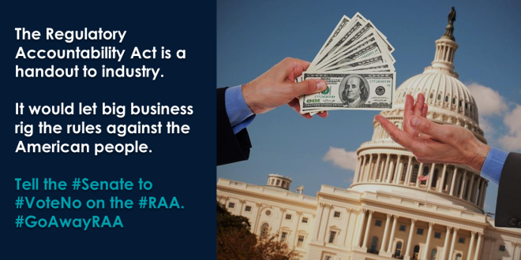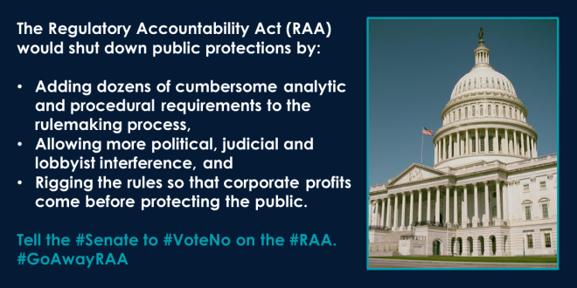

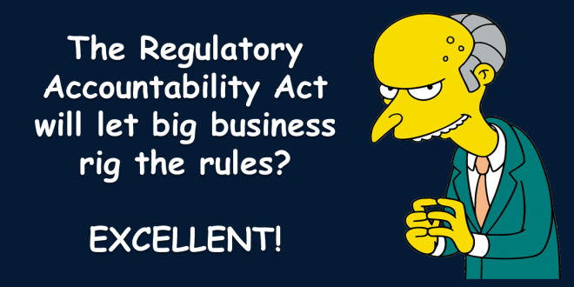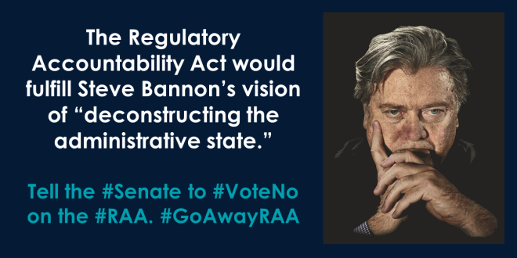

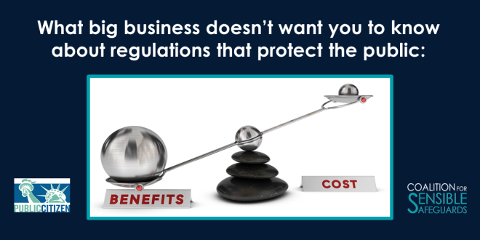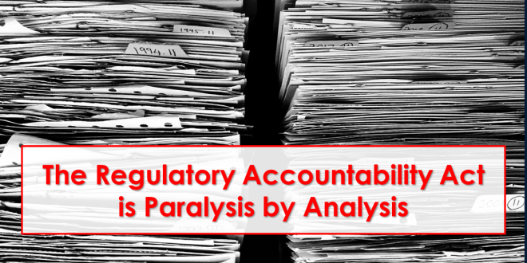

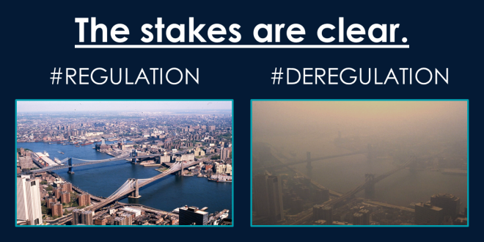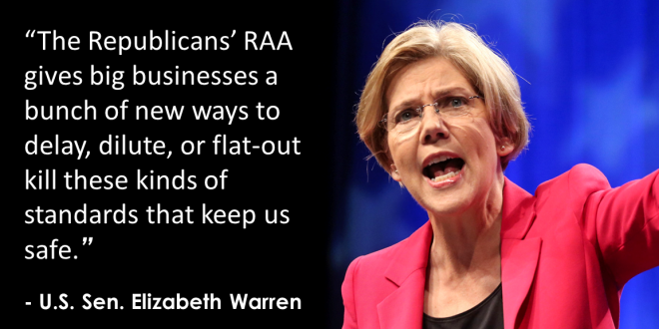

Follow the Coalition for Sensible Safeguards on Twitter @regsrock and check the hashtag #GoAwayRAA to find even more images related to the RAA.

Rebranding the RAA

Another way to talk about the RAA is by rebranding the bill as a “License to ____” for big corporations. You are encouraged to pick a verb that addresses your concerns and priorities (e.g. License to Pollute, License to Discriminate, License to Poison, License to Steal, etc.). Below is additional messaging guidance to help you use this approach.

Americans demand clean air and water, depend on safe products and want big corporations that act irresponsibly to be held accountable when they put kids and consumers in harm’s way.

The RAA would ensure the opposite. It would prevent new protections from pesticides and deadly bacteria like salmonella. It would block safeguards from known carcinogens like asbestos. And it would stop measures that would keep children from being harmed by lead-tainted drinking water.

That’s why the RAA should be called the “License to ____ Act.” It would give big corporations a free hand to pollute at will and to sell dangerous products – leaving our kids and our families exposed to these dangers with little recourse.

Big corporations and polluters would benefit while workers, consumers and families would get sick. Under this bill we could have toxic toys, lethal lunchboxes and filthy food. The Senators supporting this bill have turned their backs on American families.

Here are some of the specific protections the bill could block:

- The U.S. Department of Agriculture could be blocked from updating safety standards for meat and poultry inspections and other food.
- The U.S. Environmental Protection Agency could be blocked from strengthening rules to protect Americans from lead-contaminated drinking water and the agency’s efforts to regulate cancer-causing asbestos could be stymied.
- The Federal Aviation Administration could be blocked from adopting safety measures to reduce the number of aircraft accidents and near misses.
- The Nuclear Regulatory Commission could be blocked from setting rules to reduce the risk of a nuclear disaster like Fukushima.
- The National Highway Traffic Safety Administration could be blocked from setting safety standards for emerging technology, like driverless cars.
- The Mine Safety and Health Association could be blocked from updating protections for worker safety.
- The Food and Drug Administration could be blocked from issuing rules to fight the opioid epidemic.

Links and Petitions

Here are some links and resources to help you learn more about the issues, keep up with the latest news about the RAA and get involved.

Coalition for Sensible Safeguards Index of Resources:
http://sensiblesafeguards.org/issues/regulatory-accountability-act/

Petition hosted by Public Citizen:
http://action.citizen.org/p/dia/action3/common/public/?action_KEY=13379

Petition hosted by the Natural Resources Defense Council:
https://secure.nrdconline.org/site/Advocacy?cmd=display&page=UserAction&id=4239&s_src=STLRAAPETNON0417&_ga=2.219177435.396032829.1495054420-928012005.1477497648

Petition hosted by Americans for Financial Reform:
https://actionnetwork.org/letters/no-corporate-con-job-stop-the-regulatory-accountability-act?source=05112017&link_id=0&can_id=9365ff44103ebcd4783b9366618a024b&email_referrer=deregulatory-debacle-2&email_subject=deregulatory-debacle

Petition hosted by the Union of Concerned Scientists:
https://secure.ucsusa.org/onlineactions/LgNHDmNAoUyEzXfJ_2JGmw2

###

